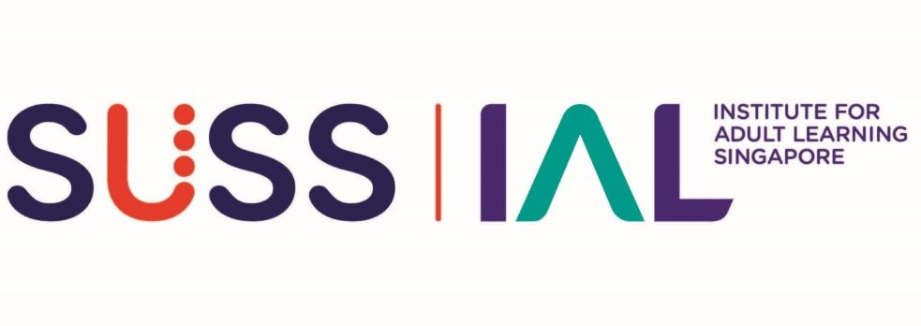
ONE-STOP SKILLS CREDENTIALING - SKILLS BADGE

Self-Assessment Form

SALUTATION**  ** Delete accordingly | Mr / Miss / Mdm / Ms / Dr / Prof
FULL NAME (as per NRIC)*
*Underline Surname

IMPORTANT: Before you submit this Self-Assessment Form, please save this Word document and rename using the following naming convention:

For Stage 1 Advisory Chat:
OSSC_Skills_Badge_ACLP03_Self Assessment_YOUR FULL NAME_v1.0_draft.doc

For Stage 2 Assessment Interview:
OSSC_Skills_Badge_ACLP03_Self Assessment_YOUR FULL NAME_v1.0_FINAL.doc

To proceed to Stage 2 Assessment Interview…
- Collate all relevant evidence/artefact pertaining to your finalised Self-Assessment Form in a single folder and name the folder according to the Badge Title as stated above.
- If applying for more than one skills badge, submission should be done in separate folders according to the badge titles.
To be completed by Advisor:
NAME OF ADVISOR
ADVISORY CHAT SESSION | Date: (dd/mm/yyyy)
Proceed to Skills Assessment? | ☐ Yes | ☐ No
☐ I confirm I have completed Stage 1 of the OSSC Skills Badging Application for Basic Package: Skills Advisory (1 hr).

☐ I confirm I have completed Stage 1 of the OSSC Skills Badging Application for Extended Package: Skills Advisory (2 hr).

IMPACT MONITORING & EVALUATION: ASSESSMENT DESIGN IMPLEMENTATION
(A)  Competency Statement  Read carefully to ensure you meet ALL requirements | (B)  Product Evidence  Check the boxes to confirm that you currently have the required evidence listed here | (C)  Applicant’s Note of Explanation  Note the given pointers to guide you in the preparation for the Skills Advisory and Assessment Interview sessions. Explain with brief notes to explain how the Product Evidence you intend to submit fulfils the requirements of columns (A) and (B). | (D)  Assessor’s comments  (For IAL use only)
- Select and apply assessment methods and tools in consideration of features and rules that guide effective learning assessments | ☐ Authentic Assessment tool and methods that effectively measure the extent that learning goals have been achieved. | - Be ready at the interview, to:  - Explain the components and the features of the selected assessment tool in relation to learning goals.  - Relate basic principles of assessment to the selected assessment tools and conduct of assessment.  - Point out indicators and measurements of learning success.  Applicant’s Notes: | For Assessor’s comments
- Prepare for and conduct assessment | ☐ Briefs/ written communication and/or presentation materials to learners/stakeholders to prepare them for the assessment.  ☐ If available, logistic checklists may also be submitted. | - You should be able to describe what was done:  - To support learners in their preparedness for assessment, and during the assessment  - To get ready tools, resources and venues.  - In the actual conduct of the assessment  Applicant’s Notes: | For Assessor’s comments
- Provide assessment results and feedback to learners/ stakeholders  - Review the effectiveness of assessment in measuring learning success | ☒ Individual assessment record and/or Summary Report of assessment results (Personal information of learner i.e. Name & ID No. should be blanked out)  AND/OR  ☐ Records of feedback to learners on their performance in assessment and areas of improvement (Personal information of learners i.e. Name & ID No. should be blanked out)  ☐ Records of review provided to management or client of assessment outcomes (E.g., programme evaluation reports or analysis of learning effectiveness. | - Be ready to elaborate on:  - How assessment result decisions were reached based on selected methodology  - How results and feedback on learning performance were conveyed to the learners/stakeholders  - Prepare to give your reflections on  - What the assessment results showed about the effectiveness of the learning design and/or assessment design.  - What improvements were made/could be made to the assessment and/or to the learning programme  Applicant’s Notes: | For Assessor’s comments

