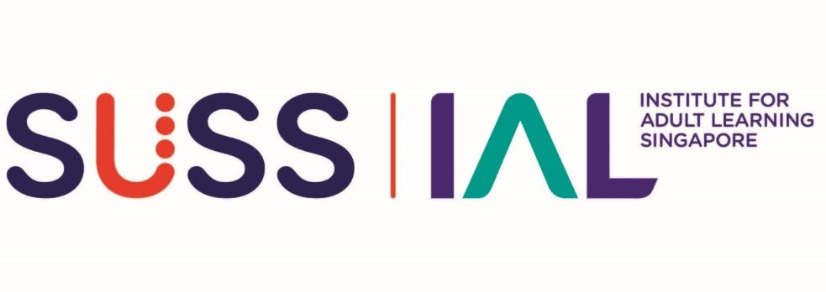

ONE-STOP SKILLS CREDENTIALING - SKILLS BADGE
Self-Assessment Form

Badge Title:
ASSESSMENT DESIGN

SALUTATION**  ** Delete accordingly | Mr / Miss / Mdm / Ms / Dr / Prof
FULL NAME (as per NRIC)*
*Underline Surname

IMPORTANT: Before you submit this Self-Assessment Form, please save this Word document and rename using the following naming convention:

For Stage 1 Advisory Chat:
OSSC_Skills_Badge_DDDLP04_ALP_Self Assessment_YOUR FULL NAME_v1.0_draft.doc

For Stage 2 Assessment Interview:
OSSC_Skills_Badge_DDDLP04_ALP_Self Assessment_YOUR FULL NAME_v1.0_FINAL.doc

To proceed to Stage 2 Assessment Interview…
- Collate all relevant evidence/artefact pertaining to your finalised Self-Assessment Form in a single folder and name the folder according to the Badge Title as stated above.
- If applying for more than one skills badge, submission should be done in separate folders according to the badge titles.
To be completed by Advisor:
NAME OF ADVISOR
ADVISORY CHAT SESSION | Date: (dd/mm/yyyy)
Proceed to Skills Assessment? | ☐ Yes | ☐ No
☐ I confirm I have completed Stage 1 of the OSSC Skills Badging Application: Skills Advisory (1 hr).

INTERVENTION DESIGN AND DEVELOPMENT: ASSESSMENT DESIGN
(A)  Competency Statement  Read carefully to ensure you meet ALL requirements | (B)  Product Evidence  Check the boxes to confirm that you currently have the required evidence listed here | (C)  Applicant’s Note of Explanation  Note the given pointers to guide you in the preparation for the Skills Advisory and Assessment Interview sessions. Explain with brief notes to explain how the Product Evidence you intend to submit fulfils the requirements of columns (A) and (B). | (D)  Assessor’s comments  (For IAL use only)
1. Design a holistic Assessment Framework for a curriculum to assess the attainment of curriculum outcomes and applying relevant assessment trends and emerging practices. | ☐ An authentic assessment framework that I have developed on my own for a  programme or curriculum which has AT LEAST TWO (2) modules.  ☐ Artefacts that show clearly the assessment design process, with defined learning objectives, outcomes, and based on competency statements that the programme is targeting.  ☐ The lesson plan and learning contents for which the assessment was developed. | I can point out and provide a walk-through of the following in the assessment framework I have submitted:  ☐Well-defined learning objectives that is derived from the Technical Skill and Competency (Skills Framework) or from a competency standard (WSQ or non-WSQ)  ☐Clearly defined assessment purpose that is holistically aligned to the learning objectives, assessment criteria, content and outcomes.  ☐ Clearly defined assessment pathway(s), types of assessment, and assessment methods.  ☐ AT LEAST TWO (2) assessment design consideration relating to learner profile and curricular objectives.  Applicant’s Notes:  I am able to show that my assessment plan:  ☐ Has considered at least TWO (2) assessment trends impacting assessment design.  Applicant to note:  The trends may include any TWO (2) of the impacts on:  - Types of assessment, assessment pathways and assessment methods.  - Collection of evidence for the assessment.  - Process of conducting assessment.  - Principles of Assessment and Rules of Evidence.  - Candidates or Assessors.  Types of assessment may include: Formative, Summative, continuous, Sustainable, Diagnostic, Skills recognition, Ipsative  Principles of Assessment may include the following:  - Validity, reliability, authenticity, equitability, flexibility. (SUSS)  - Fairness, Flexibility, Reliability and Validity (WSQ/Australian Skills Quality Authority), etc.  Applicant’s Notes: | For Assessor’s comments
2. Plan for and develop assessment, selecting methods, tools and the evidence to be collected to assess learning achievement. | ☐ An Assessment Plan that I have developed for a Learning Unit of AT LEAST SEVEN (7) hours with accompanying learning content and courseware | The assessment plan I submitted demonstrates constructive alignment between assessment and learning as supported by the following:  ☐ Learning outcomes mapped to Ability and Knowledge Statement  ☐ A lesson plan with at least 7 hours of learning  ☐ Learning content and courseware  The assessment included:  ☐ AT LEAST ONE (1) type of assessment  ☐ AT LEAST ONE (1) assessment pathways  ☐ AT LEAST TWO (2) assessment methods  ☐ Alignment to THREE (3) Principles of Assessment  ☐ Assessment criteria that adhere to Rules of Evidence.  Applicant: to note:  Assessment Pathways may include Facilitated learning & assessment, Assessment only, Composite, Practicum-based, Recognition of prior learning, etc.  Rules of Evidence refers to Validity, Sufficiency, Currency, Authenticity  ☐ A wholistic/analytical rubric or score sheet  ☐ An Evidence Gathering Plan which lists the types of evidence to be gathered. Evidence submitted included AT LEAST TWO (2) types of evidence.  There were complete assessment tools to support each selected assessment method including:  ☐ Assessment Record that defined Abilities, Knowledge, Performance Statements, Underpinning Knowledge, etc. to be assessed, with list of questions and suggested answers.  ☐ Specification Table or detailed plan for each assessment method  ☐ Clear and detailed instructions to Assessors and Candidates  ☐ Relevant assessment instruments such as case studies, role-play scripts, checklists, test questions and answers etc. for each assessment tool.  ☐ Logistic checklist to prepare for the specific assessments such as floor plan for props set up, audio-visual equipment needed, stationery, office furniture, etc.  Applicant’s Notes:
3. Validate the assessment plan and assessment results with stakeholders to review its effectiveness | ☐ Clear evidence of a complete validation process that was conducted to validate the Assessment Plan such as a Validation Report, notes of meeting or coherent trail of email or written communication from stakeholders.  ☐ Documented analysis on the effectiveness of Assessment Methods and Tools on Learner Progress | Note to Applicant:  You need to be able to show how in validation, you related the Assessment Plan to the Lesson Plan, assessment methods and tools.  I am able to show and elaborate on :  ☐ Evidence of a meeting/session with Client Organisation’s key stakeholder(s) AND/OR proof of the validation via notes of meeting or confirmation email to review and validate the Assessment Framework and Assessment Plan.  ☐ I can point out and discuss from my Validation Report or documented evidence of validation, the details of the following:  - Who the stakeholders involved in the Validation were.  - Purpose of Validation  - Context of Validation  - Validation approach  ☐ I can show and elaborate on the analysis on the effectiveness of Assessment Methods and Tools to measure Learner Progress  I can show and discuss:  ☐ AT LEAST TWO (2) issues/comments AND/OR strengths or weaknesses on the Assessment Framework  ☐ AT LEAST TWO (2) outcomes (i.e. result or decisions and actions taken) by the validation process members.  Applicant’s Notes:
4. Evaluate quality assurance  issues in assessment tools and  methods | As in rows above | I can show evidence of my input and/or recommendation into strategies to improve Quality Assurance (QA) issues in assessment in the Practice/Client Organisation.  Applicant’s Notes:

